**DBMS LAB 8**

**PROGRAM 8: STUDENT ENROLLMENT DATABASE**

Consider the following database of student enrollment in courses and books adopted for each course.

STUDENT (regno: String, name: String, major: String, bdate: date)  
COURSE (course #: int, cname: String, dept: String)  
ENROLL (regno: String, cname: String, sem: int, marks: int)  
BOOK_ADOPTION (course #: int, sem: int, book-ISBN: int)  
TEXT (book-ISBN:int, book-title:String, publisher: String, author: String)

i. Create the above tables by properly specifying the primary keys and the foreign keys.

**CREATE TABLE student**

**(**

**regno VARCHAR(15),**

**name VARCHAR(20),**

**major VARCHAR(20),**

**bdate DATE,**

**PRIMARY KEY (regno)**

**);**

**CREATE TABLE course**

**(**

**courseno INT,**

**cname VARCHAR(20),**

**dept VARCHAR(20),**

**PRIMARY KEY (courseno)**

**);**

**CREATE TABLE enroll**

**(**

**regno VARCHAR(15),**

**courseno INT,**

**sem INT(3),**

**marks INT(4),**

**PRIMARY KEY (regno,courseno),**

**FOREIGN KEY (regno) REFERENCES student (regno),**

**FOREIGN KEY (courseno) REFERENCES course (courseno)**

**);**

**CREATE TABLE text**

**(**

**book_isbn INT(5),**

**book_title VARCHAR(20),**

**publisher VARCHAR(20),**

**author VARCHAR(20),**

**PRIMARY KEY (book_isbn)**

**);**

**CREATE TABLE book_adoption**

**(**

**courseno INT,**

**sem INT(3),**

**book_isbn INT(5),**

**PRIMARY KEY (courseno,book_isbn),**

**FOREIGN KEY (courseno) REFERENCES course (courseno),**

**FOREIGN KEY (book_isbn) REFERENCES text(book_isbn)**

**);**

ii. Enter atleast five tuples for each relation.

**INSERT INTO student (regno,name,major,bdate) VALUES**

**('1pe11cs001','a','sr',19931230),**

**('1pe11cs002','b','sr','19930924'),**

**('1pe11cs003','c','sr','19931127'),**

**('1pe11cs004','d','sr','19930413'),**

**('1pe11cs005','e','jr','19940824');**

**INSERT INTO course VALUES**

**(111,'OS','CSE'),**

**(112,'EC','CSE'),**

**(113,'SS','ISE'),**

**(114,'DBMS','CSE'),**

**(115,'SIGNALS','ECE');**

**INSERT INTO text VALUES**

**(10,'DATABASE SYSTEMS','PEARSON','SCHIELD'),**

**(900,'OPERATING SYS','PEARSON','LELAND'),**

**(901,'CIRCUITS','HALL INDIA','BOB'),**

**(902,'SYSTEM SOFTWARE','PETERSON','JACOB'),**

**(903,'SCHEDULING','PEARSON','PATIL'),**

**(904,'DATABASE SYSTEMS','PEARSON','JACOB'),**

**(905,'DATABASE MANAGER','PEARSON','BOB'),**

**(906,'SIGNALS','HALL INDIA','SUMIT');**

**INSERT INTO enroll (regno,courseno,sem,marks) VALUES**

**('1pe11cs001',115,3,100),**

**('1pe11cs002',114,5,100),**

**('1pe11cs003',113,5,100),**

**('1pe11cs004',111,5,100),**

**('1pe11cs005',112,3,100);**

**INSERT INTO book_adoption (courseno,sem,book_isbn) VALUES**

**(111,5,900),**

**(111,5,903),**

**(111,5,904),**

**(112,3,901),**

**(113,3,10),**

**(114,5,905),**

**(113,5,902),**

**(115,3,906);**

iii. Demonstrate how you add a new text book to the database and make this book be adopted by some   
department.

**INSERT INTO text VALUES (906,'SIGNALS','HALL INDIA','SUMIT');**

**INSERT INTO book_adoption VALUES (115,3,906);**

iv. Produce a list of text books (include Course #, Book-ISBN, Book-title) in the alphabetical order for courses offered by the ‘CS’ department that use more than two books.

**SELECT c.courseno,t.book_isbn,t.book_title FROM course c,book_adoption ba,text t**

**WHERE c.courseno=ba.courseno AND ba.book_isbn=t.book_isbn AND c.dept='CSE' AND 2<( SELECT COUNT(book_isbn) FROM book_adoption b WHERE c.courseno=b.courseno) ORDER BY t.book_title;**

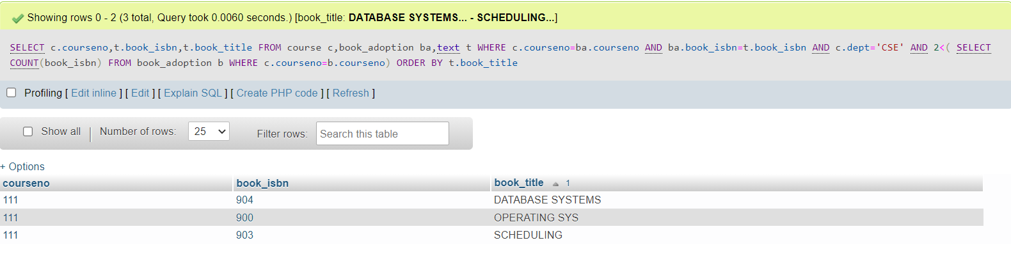

v. List any department that has all its adopted books published by a specific publisher.

**SELECT DISTINCT c.dept FROM course c WHERE c.dept IN (SELECT c.dept**

**FROM course c,book_adoption b,text t WHERE c.courseno=b.courseno AND**

**t.book_isbn=b.book_isbn AND t.publisher='PEARSON');**

